CONTACT: Nancy Richards – 917-873-6389 (cell) /nancy@northcoastrep.org
MEDIA PAGE: www.northcoastrep.org/press
FOR IMMEDIATE RELEASE, PLEASE:

NORTH COAST REP DELIVERS THE FABULOUS FUN
OF FORBIDDEN BROADWAY’S GREATEST HITS
Created & Written by Gerard Alessandrini
Performances Beginning Wednesday, April 20, 2022
Running Through Sunday, May 22, 2022
Directed By William Selby

Solana Beach, Calif. – North Coast Repertory Theatre is celebrating unforgettable musical legends with a wildly funny send-up of The Great White Way. FORBIDDEN BROADWAY’S GREATEST HITS parodies beloved musicals including Chicago, Phantom, Wicked, Fiddler and many more with wit, charm and hysterical lyrics. This brilliant satire pays loving tribute to some of the theatre’s most cherished stars and songwriters. Endlessly entertaining, this show has endeared itself to audiences the world over. Early ticket sales have been booming, so make reservations now to avoid disappointment.

William Selby* directs and acts with Cathy Barnett*, Trisha Rapier* and Edward Staudenmayer* in FORBIDDEN BROADWAY’S GREATEST HITS. Elan McMahan is the Musical Director and Pianist. The Creative Team includes Marty Burnett (Scenic Design), Matthew Novotny (Light Design), Dustin Cross (Costume Designs), Elisa Benzoni (Costume Consultant), Aaron Rumley (Sound Design), and Philip Korth (Covid-19 Compliance Officer/Props). Stage Manager is Cindy Rumley*.
*The actor or stage manager appears through the courtesy of Actors’ Equity Association. For photos, go to www.northcoastrep.org/press.

FORBIDDEN BROADWAY previews begin Wednesday, April 20. Opening Night on Saturday, April 24, at 8pm. There will be a talk back on April 29th, with the cast and artistic director. It will play Wednesdays at 7pm, Thursdays through Saturdays at 8pm, Saturday and Sunday matinees at 2pm with Sundays at 7pm through May 22nd. (See Schedule below). North Coast Repertory Theatre is located at 987 Lomas Santa Fe Drive, Solana Beach, CA 92075. Tickets: Previews - $54 (including Friday previews at 2pm & 8pm), Week Nights/Wed. & Sat. Matinees - $60; Sat. Eve. & Sun. Mat. $65; Sun Night - $57. Seniors, Students, Military & Educators - $3 off admission. Call 858-481-1055, or visit www.northcoastrep.org to purchase tickets.
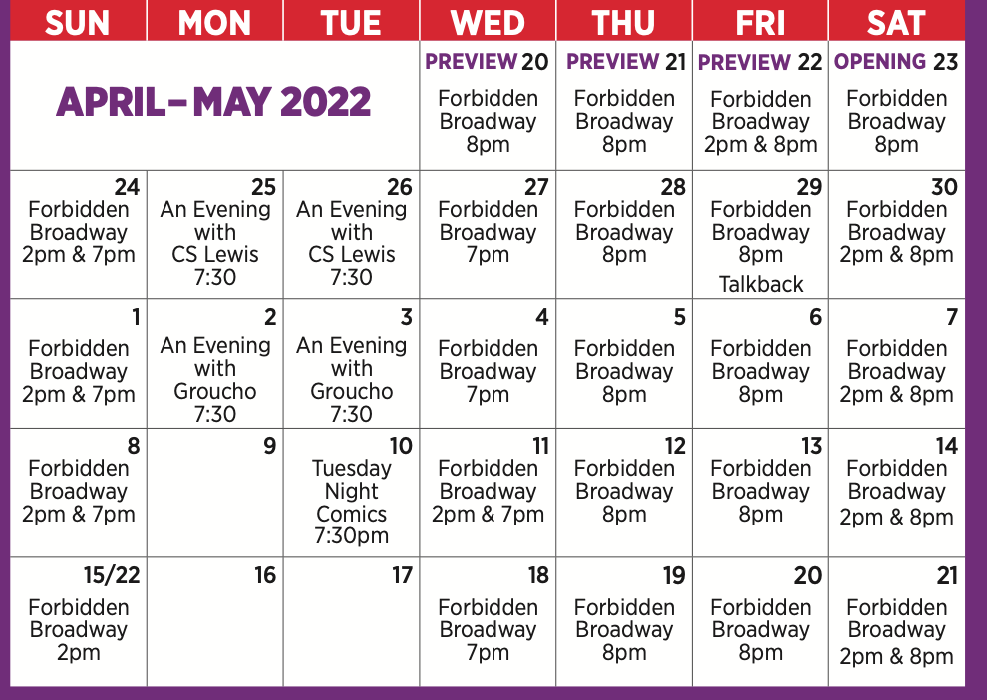

FACT SHEET:

WHAT: NORTH COAST REPERTORY THEATRE presents
FORBIDDEN BROADWAY’S GREATEST HITS
Created & Written by Gerard Alessandrini
Directed by William Selby

CAST: Cathy Barnett, Tricia Rapier, William Selby, Edward Staudenmayer
WHERE: North Coast Repertory Theatre
987 Lomas Santa Fe Drive
Solana Beach, CA 92075

SCHEDULE: Previews start April 20, 2022
Opens: April 24, 2022
Closes: May 15, 2022
Wed. @ 7pm, Thurs-Sat @ 8PM; Sat & Sun @ 2PM, Sun @ 7pm
Fri (April 22) @ 2pm & 8pm
Wed (May 11) @ 2pm & 7pm

PRICES: Previews $54.00
Week Nights & Sat. Matinees $60.00
Sat. Nights & Sunday Matinees $65.00
Sunday Nights $57.00

DISCOUNTS: Seniors, Students, Military & Educators $3.00 off admission. Rush tickets available for $20. 15 minutes prior to showtime.
BIOS:
GERARD ALESSANDRINI (Creator, Writer, Director) Spamilton: (Creator/ Writer/Director): New York, London, Chicago, Los Angeles, National Tour. Forbidden Broadway (creator/ writer/ director): 25 editions all over the world. Also Forbidden Hollywood (writer/director), Madame X: The Musical (NYMF) (co-writer/director), The Nutcracker & I (lyrics), Maury Yeston’s review Anything Can Happen in New York. Television: special material for Carol Burnett, Angela Lansbury and Bob Hope. Film: “Aladdin,” “Pocahontas” (vocals). Recordings: 12 Forbidden Broadway cast albums, Forbidden Hollywood & Spamilton cast albums. Special Lyrics: Barbra Streisand Duets 2. Awards: Drama League Lifetime Achievement Award, Obie Award, 2 Lucille Lortel Awards, 7 Drama Desk (2 Best Lyrics, 2 Special Achievement, 3 Best Musical Revue), and a Special Tony Award for Lifetime Achievement in Theatre.

WILLIAM SELBY (Director/Performer) Bill performed for many years in the Off-Broadway smash revue, Forbidden Broadway, and has directed 19 productions of the show across the country, including the 2012 Ovation Award winner for ‘Best Musical’ in Long Beach, CA. Also Off-Broadway (as performer): The Daring Duo (Bridge Theatre), Nerds (NY Musical Theatre Festival), Forbidden Hollywood (Triad), Juba (Vineyard), The Apple Tree (York). NY Workshop: Finding Nemo for Disney (Mr. Ray/Gill). Regional: Bernadette in the Gateway and Ogunquit Playhouse co-productions of Priscilla, Queen of the Desert (Broadway World Award nomination), Luther Billis in South Pacific at the Ivoryton Playhouse (Broadway World & CT Critics Circle Award nominations for Outstanding Supporting Actor), Barrymore, The Presidents (with Rich Little), Hot n’ Cole, The All Night Strut. He comes to North Coast Rep direct from Sarasota, FL, where he was appearing in the revue, Laughing Matters, Vol. 6, with Florida Studio Theatre. He performed three other revues there in the past, along with a most joyous production of Bright Star, playing Daddy Cane/Stanford.

CATHY BARNETT (Performer) is delighted to return to North Coast! She has toured nationally and internationally in productions of both Forbidden Broadway and Forbidden Hollywood. Cathy is a professional actress and voice-over artist based in Kansas City, Missouri, where she has appeared in numerous productions including The Producers, Sweeney Todd, The Addams Family Musical, Hairspray and Grey Gardens. She most recently portrayed Minnie Pearl in the Kansas City world premiere of Johnny and June, a Johnny Cash tribute concert. She voices the Hallmark greeting card character, “Maxine,” and brought her to life in the new live musical, Maxine’s Christmas Carol.

TRISHA RAPIER (Performer) is thrilled to return to be making her North Coast Repertory debut with Forbidden Broadway. Trisha’s Broadway and National Tour credits include: The Boy from Oz starring Hugh Jackman (Liza Minnelli u/s and performed), Sister Act (Sister Mary Martin of Tours, Mother Superior u/s and performed) The Who’s Tommy (Mrs. Walker u/s and performed), and Forbidden Broadway/Hollywood (Barbra Streisand, Marlene Dietrich, etc.) Some Off-Broadway credits include: The World Goes ‘Round, Sessions (Mary), Lorenzo (Anna Grahl), Her Song at Birdland, Shout! The Mod Musical, Nerds:// A Musical Software Satire (Myrtle), NEWSical (Trisha), Golf: The Musical (Trisha) and Forbidden Broadway. Trisha’s favorite regional credits are Diana in Next To Normal, Rose Stopnick in Caroline, or Change, Vicki Nichols in The Full Monty, Eva in Evita , Sally Bowles in Cabaret, Ellen in Miss Saigon, Audrey in Little Shop of Horrors, Adelaide in Guys and Dolls , and Agnes in Agnes of God. She can be seen on Cartoon Network’s “Delocated.” She is a UCLA graduate and the recipient of the Carol Burnett Award and the Spotlight Award of the Los Angeles Music Center. Trisha is currently working on a one woman show celebrating the music and careers of Linda Ronstadt, Liza Minnelli and Barbra Streisand. www.TrishaRapier.com

EDWARD STAUDENMAYER (Performer) recently reopened Broadway in Girl from the North Country. He was starring in the National Tour of Anastasia as Vlad Popov when the theaters shut down in March 2020. Broadway: Wonderland, Martin Short: Fame Becomes Me. Tours: Phantom of the Opera, Anything Goes (Helen Hayes Nomination) Beauty and the Beast (National Theater Award Nomination), Joseph…, Radio City Christmas Spectacular, The Scarlet Pimpernel. Other: 28 years with Forbidden Broadway (3 Cast Recordings) Spamalot (Vegas), Spamilton, South Pacific, A Room With A View, Children of Eden, Bye Bye Birdie, 1776, Exactly Like You, The Great Ostrovsky (Barrymore Nomination), Breaking Up Is Hard To Do, 9 to 5, Newsical, The Nutcracker and I, On The Twentieth Century, Noises Off, Jane Eyre, Gigi, The Producer’s, Cats (Hamburg). Also “MTV’s Celebrity Deathmatch” and upcoming feature film “A Thousand and One.” UCLA Graduate where he received the Carol Burnett Award. AEA, SAG, AFTRA, AGVA member.
ELAN MCMAHAN (Musical Director/Pianist) is pleased to make her NCRT debut. She has been an active part of the musical scene in San Diego for over 30 years. Her work is regularly heard on many local stages, including The Old Globe and Moonlight Stage Productions. She has received three Craig Noel Outstanding Musical Direction Awards from the San Diego Critics Circle, most recently for Moonlight’s 2017 production of In the Heights. Elan holds music degrees from Brigham Young University and the St. Louis Conservatory of Music. She is an associate faculty member at MiraCosta College.
CINDY RUMLEY* (Stage Manager) Credits include: Desperate Measures, Dancing Lessons, Another Roll of the Dice, All in the Timing, Holmes & Watson, A Funny Thing..., How The Other Half Loves, Last of the Red Hot Lovers, The Spitfire Grill, Laughter on the 23rd Floor, Ain’t Misbehavin’, Way Downriver; William Faulkner’s ‘Old Man’, Chapatti, Side By Side By Sondheim, Freud’s Last Session, Mandate Memories, Dames at Sea, Two By Pinter, and Visiting Mr. Green with North Coast Rep. Cindy holds an M.F.A in stage management from UC Irvine.
CREATIVE STAFF
MARTY BURNETT (Set Design) Resident Designer at North Coast Rep since 1992 and has designed more than 200 productions for the theater. Other design venues include Sahara and Hacienda hotels in Las Vegas, Claridge Hotel, Atlantic City and Drury Lane Chicago.
MATTHEW NOVOTNY (Light Design) is pleased to be designing another show for North Coast Rep, where he has designed close to forty shows over the past seven years. Matthew is currently the Lighting Designer in Residence for San Diego Musical Theatre as well as North Coast Rep, and his work can be seen at a wide variety of theatres across San Diego. Matthew holds a B.A. in Technical Theatre from San Diego State and a master’s degree in Lighting Design from Boston University. Matthew is married to his beautiful wife Amanda, with 5 AMAZING children: Ragan, Harper, Heston, Maddex and Harrison.
DUSTIN CROSS (Costume Design) is so happy to be back with his Forbidden Broadway family! Off Broadway (Select): Spamilton (New York, Chicago, Pittsburgh, LA, London, National Tour), The Office (NY, National Tour) The Glass Menagerie, A Midsummer Nights Dream, Cougar The Musical, The Other Josh Cohen, Forbidden Broadway: Comes Out Swinging. Regional (Select): The Witches of Eastwick, Billy Elliot, Cinderella, Sister Act, Grumpy Old Men, The Little Mermaid, Noises Off, From Here to Eternity, Heartbreak Hotel, West Side Story, Hello Dolly, The Christmas Rose (Carnegie Hall), Prince of Egypt, The NY Knicks Dancers and The NY JETS Drumline. Film: Celtic Heart (PBS), Buttons (starring Dick Van Dyke and Angela Lansbury). Enjoy! dustincrossdesigns.com.
ELISA BENZONI+ (Costume Consultant) is thrilled to be working on her fourth season at
North Coast Rep including numerous Craig Noel nominated productions. Elisa has also worked on over a hundred productions across Southern California with theatres such as The Old Globe, La Jolla Playhouse, Geffen Playhouse, South Coast Repertory Theatre, Laguna Playhouse, San Diego Repertory Theatre, Diversionary Theatre and New Village Arts. Being Italian-born, Elisa has also had the opportunity to work and perfect her craft in Europe. Elisa holds a costume design M.F.A. from UCSD where she currently is an adjunct professor. www.elisabenzoni.com
AARON RUMLEY (Sound Designer) has worked on over 120 shows at North Coast Rep, over 50 as a stage manager, over 20 as a designer.
PHILLIP KORTH (COVID-19 Compliance Officer/Props) is an actor, writer, craftsman, and educator. He earned BAs in Acting and Creative Writing from Western Michigan University and his MFA in Acting from the University of Connecticut. He is a Veteran of the United States Marine Corps and served two tours of duty in Iraq. In addition to designing and managing props for NCRT, Phillip is also the Education Associate at The Theatre School @ North Coast Rep.
About the North Coast Repertory Theatre under the artistic leadership of David Ellenstein since 2003, is a professional Equity theatre, currently celebrating its 40th Season. North Coast Rep has received critical acclaim from media and audiences alike, and has evolved into one of the area’s leading performing arts organizations. North Coast Rep prides itself on employing the majority of its actors from Actors’ Equity Association for its high quality, award‐winning productions, and staging works by established and emerging playwrights. Throughout its history, North Coast Rep has created a platform where artist and audience thrive through the intimacy of live theatre, recognizing the power of theatre to challenge complacency, revitalize the imagination, nurture the unexpected and embrace the variety and diversity in our lives.

###

